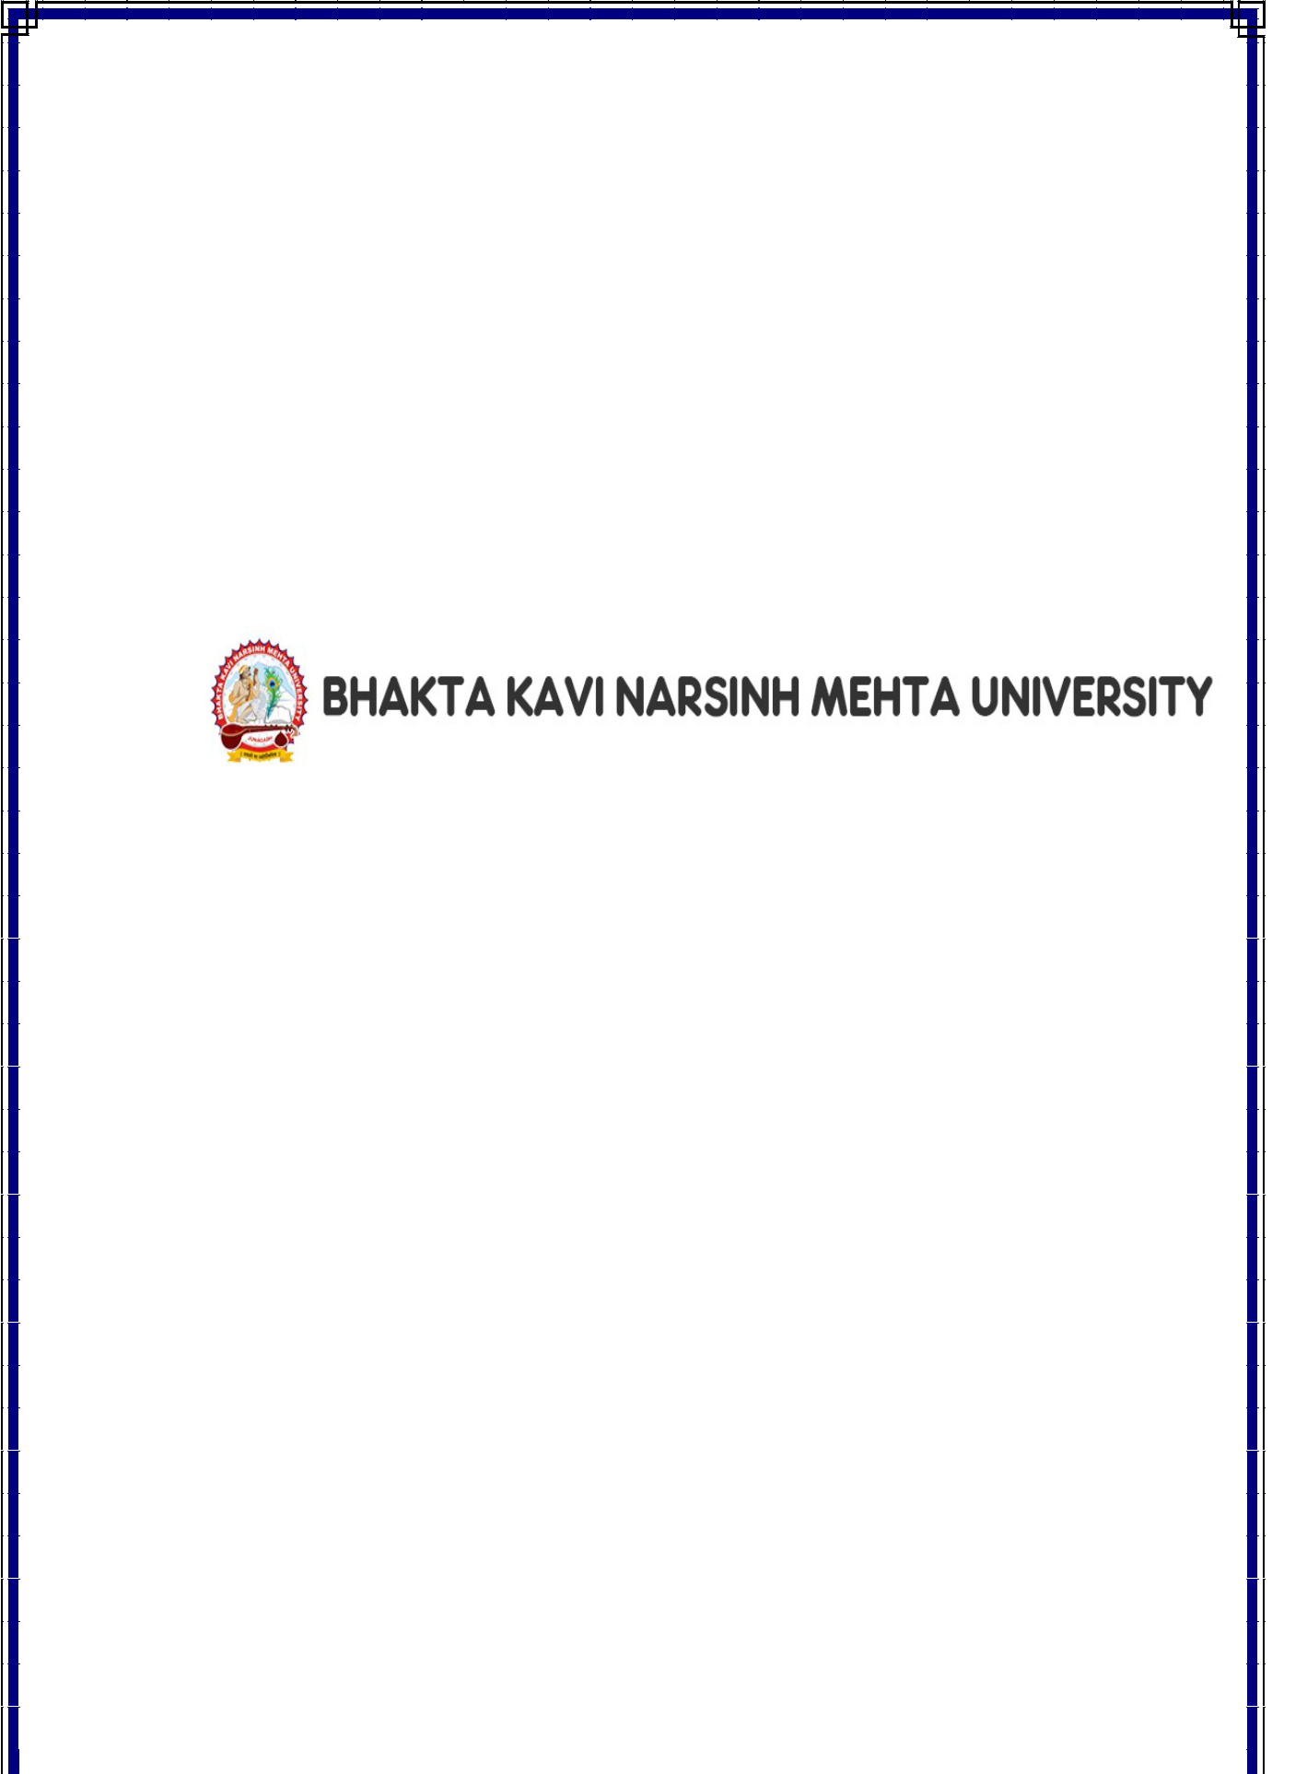
A

PROJECT REPORT

On

“Hair Studio”

BCA SEM V Project

Submitted in partial fulfilment for the BCA 5th Semester

SUBMITTED BY

Arpitkumar Vadariya (03052000397)

Jay Bhalodiya (03052000347)

Project Internal Guide Principal
(Prof. Rinku Chavda) (Dr. Vimal Parmar)



Dr. Subhash College of Computer Science Junagadh

Certificate

Enrolment No. ____________

This is to certify that the Project / practical work was satisfactorily carried out and hence submitted this report is the Bonafede work of Mr./ Ms. _____________________________________________________

Student of Bachelor of Computer Applications Sem __ in the

_____________________________ Laboratory of Dr. Subhash College

of Computer Science Junagadh during the academic year 2022-23.

_____________

________________

Internal Guide

HODD

________________

Principal

Dr. Subhash College of Computer Science Junagadh

Certificate

Enrolment No. ____________

This is to certify that the Project / practical work was satisfactorily carried out and hence submitted this report is the Bonafede work of Mr./ Ms. _____________________________________________________

Student of Bachelor of Computer Applications Sem __ in the

_____________________________ Laboratory of Dr. Subhash College

of Computer Science Junagadh during the academic year 2022-23.

_____________

________________

Internal Guide

HODD

________________

Principal


ACKNOWLEDGEMENT

I take this opportunity to express our sincere gratitude to all those who helped us in various capacities in undertaking this project and devising the report.

I am privileged to express our sense of gratitude to our respected prof. Rinku Chavda unparalleled knowledge, moral fiber and judgment along with his know-how, was an immense support in completing the project.

I am also grateful to Dr. Vimal Parmar, the Principal and all other faculties of BCA for the brainwave and encouragement given. I take this opportunity also to thank our friends and contemporaries for their cooperation and compliance.

And lastly, i would like to pay my sincere regards to my parents and to our near and dear ones whose moral support and guidance helped to complete and submit the project well before the due date.

Arpitkumar Vadariya (03052000397)
Jay Bhalodiya (03052000347)

Bachelor of Computer Applications
Dr. Subhash College of Computer
Science - Junagadh
DECLARATION

I _________________________________________________________ student of

Dr. Subhash College of Computer Science in Bachelor of Computer Application Sem 5 declares that this project is not submitted to anywhere else in the market or in any other form of use.

I also assure that no copy of this project is shared with any other student and this project is developed by us with guidance of our faculties.

Name and Signature

